Q- Why you need custom AMI to launch instance?
Ans- You need custom AMIs (Amazon Machine Images) to pre-install software, apply specific configurations, bake in security settings, and optimize environments for faster, consistent, and more secure AWS EC2 instance launches, ensuring every new server starts with your exact requirements rather than needing lengthy post-launch setup. They act as reusable templates for identical server environments, crucial for scaling, DevOps, and compliance, reducing deployment time significantly.

Creating an AMI from an existing Amazon EC2 instance
- From the AWS Toolkit Explorer, expand Amazon EC2 and choose Instances to view a list of your existing instances.
- Right-click the instance that you want to use as the basis for your AMI and choose Create Image (ABS AMI) to open the Create Image dialog window.
- From the Create Image dialog window, add a name and a description for your image into the provided fields, then choose the OK button to continue.
- The Image Created confirmation window opens in Visual Studio when the image is created, choose the OK button to continue.
Select the existing EC2 instance and under Actions, choose Image and templates. Click on Create Image
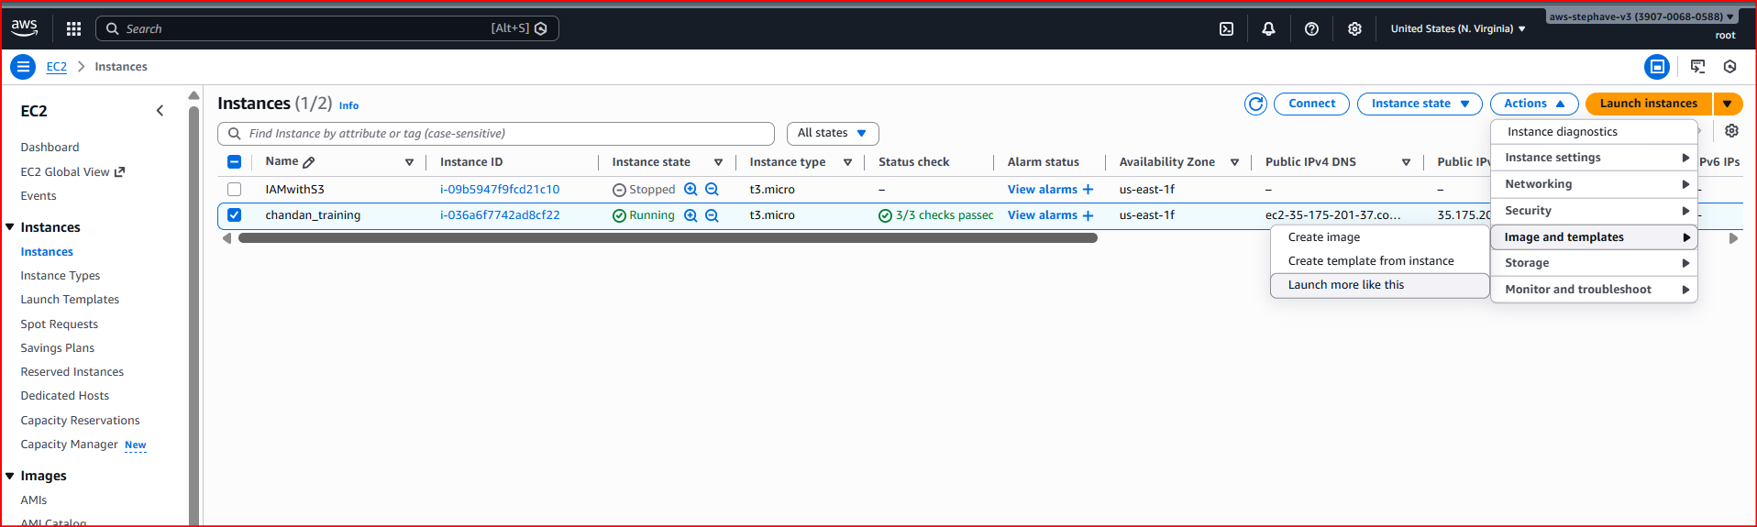
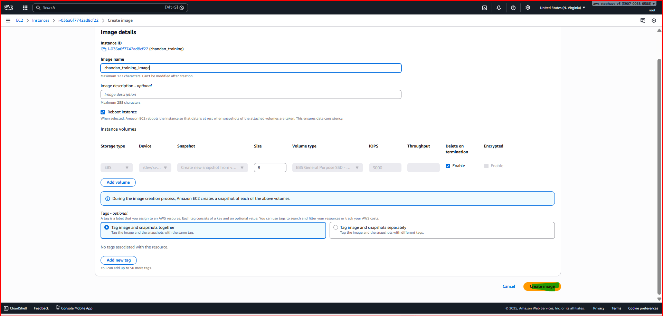

Once the Once the image is successfully created, you can view it in the AMI panel under my AMI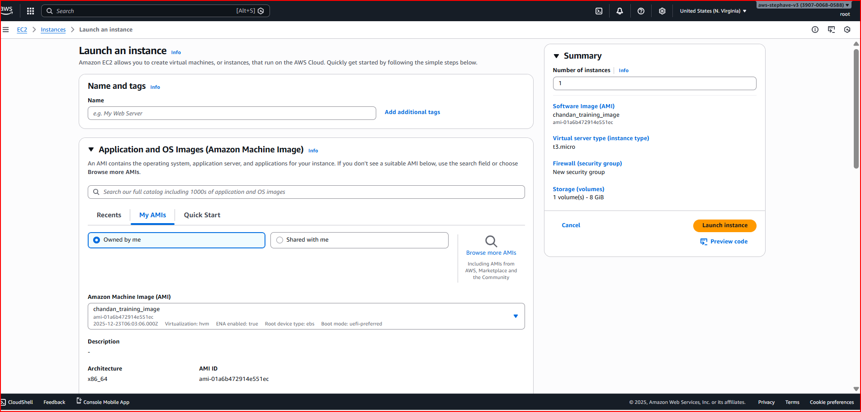

Follow the same process of launching an EC2 instance. This time select from my AMI

